2024 Recital Lineup “Kick the Dust Up”
 | Class | Dance | # of per-  formers | Hair
 | Act 1
1 | Advanced Hip Hop | Jelly Roll’d | 13 | pigtail or single braid
2 | Pre-K Tap | Get Rhythm | 8 | Sock Bun; Xander-your choice
3 | Solo-Erin | Fine On the Outside | 1 | Your choice
4 | African 2 | MAMA Africa | 11 | pigtail or single braid
5 | Adult Tap | Ain't Goin’ Down til the Sun Comes Up | 7 | Pony or Braid
6 | Pre-K Ballet | I’ll Be | 8 | Sock Bun; Xander-your choice
7 | Advanced Jazz | Jolene | 4 | High pony
8 | Solo- Chelsea | Trainwreck | 1 | Your choice
9 | Intermediate Acro | Swifties | 10 | High Pony
10 | Pre-K Acro | Chattahoochee | 7 | High Pony; Xander-your choice
11 | Beginning Ballet | Rainbow | 10
12 | Intermediate Lyrical | Safe and Sound | 13 | pigtail or single braid
13 | Solo- Grace | Hello Beautiful | 1 | Your choice
14 | Beginning Tap | Daddy’s Money | 5 | High pony
15 | Mom Dance | Redneck Fancy Daddy | 25 | Your choice
 | INTERMISSION | Mat setup
 | Act 2
16 | Advanced Acro | Country Divas | 6 | High Pony
17 | Beginning Acro | Heartbreakers | 8 | Girls: half up half down braids into low ponytail; James- your choice
18 | African1 | Calm Down- Nonna | 8 | pigtail or single braid
19 | Intermediate Tap | Be My Baby Tonight | 3 | High pony
20 | Senior Dance- Julia R. and friends | Home | 4 | Your choice
21 | Beginning Jazz | Wild One | 5 | High teased pony
22 | Advanced Tap | Parachute | 5 | pigtail or single braid
23 | Solo- Bailey | Broken Diamond | 1 | half up half down braids
24 | Adult Jazz | Thump Factor | 5 | High Pony or Braid
25 | Intermediate Ballet | If I Die Young | 5 | pigtail or single braid
26 | Intermediate Jazz | Why Don’t We Just Dance | 3 | High pony, robby slicked comb over (gel)
27 | Advanced Lyrical | Thank God I Do | 8 | half up half down
28 | Solo-Mykenzie | Take Me to Church | 1 | Your choice
29 | Intermediate Hip Hop | 5-1-5-0 | 7 | pigtail or single braid
30 | Teacher-Senior Dance/Finale | I Hope You Dance/Kick the Dust Up | 11/all | Your choice
https://www.youtube.com/watch?v=2EQW3WpVn24

This link will take you to a Youtube video that walks you through how to do a sock bun. I tried it; third time’s a charm (and I am usually the worst when trying to do my own hair…so that’s saying something!) I used my husband’s dress sock. In the video, she states that you don’t have to use bobby pins, but you do. And lots of hair spray!!!
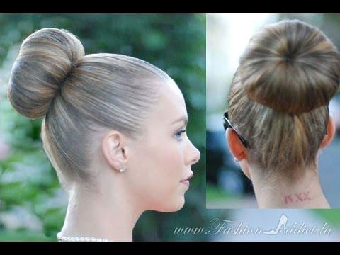

https://www.youtube.com/watch?v=S5OGEXaaPus

This shows you how to do a high ponytail (piece of hair around the hair tie is optional)

Photo of Bailey’s braids coming soon!

I would like to have all Intermediate level and higher classes do their makeup like this; beginning and Pre-K…make up is optional.
